

Title
APPLICATIONS REPORT AND EVALUATION METHODS

Date: 22nd of April, 2016
Course Code: DT228-2
Group: 10
Team Members: A.N. Other
Yeta Nother
Anda Nother
M.Mouse

Table of Contents

Introduction 1
System Requirements 1
Design Methods 2
Life Cycle Model 2
Cognitive Frameworks 3
Interaction Styles 4
Input & Output devices 4
Ubiquitous Design 4
Evaluation methods 5
Prototypes 6
Low Fidelity Prototype 6
Enhanced Low Fidelity Prototype 7
Evaluation of Low Fidelity Prototype 8
Medium Fidelity Prototype 9
Evaluation of Medium Fidelity Prototype 14
Conclusion 15
References 16
Evaluations 17

INTRODUCTION
Around half a page

SYSTEM REQUIREMENTS
Around a page

.
DESIGN METHODS
LIFE CYCLE MODEL
Around two pages with the graphics as exemplified

.
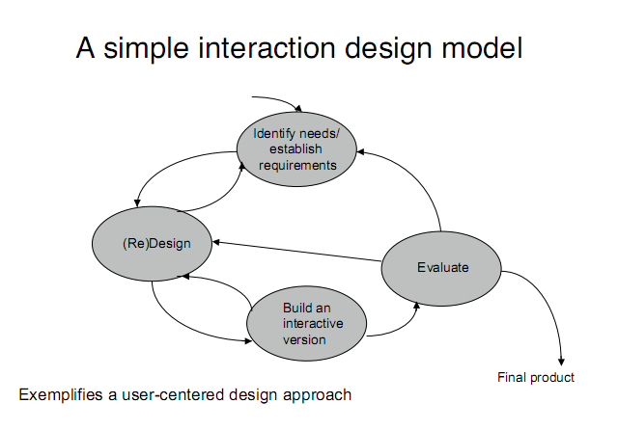
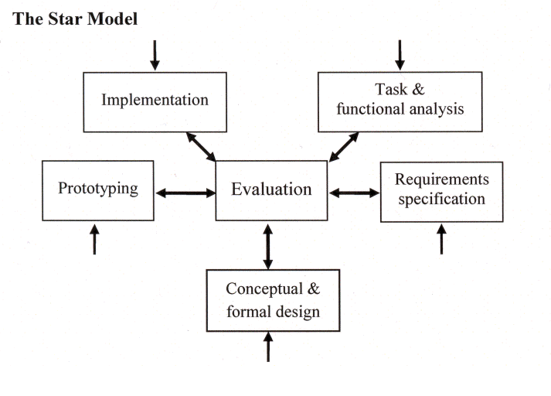

COGNITIVE FRAMEWORKS
Around a paragraph

INTERACTION STYLES
Around a paragraph

INPUT AND OUTPUT DEVICES
Around a paragraph

UBIQUITOUS DESIGN
Around half a page
EVALUATION METHODS
Around half a page
PROTOTYPES
LOW FIDELITY PROTOTYPE

Around a page - EXAMPLE graphics below

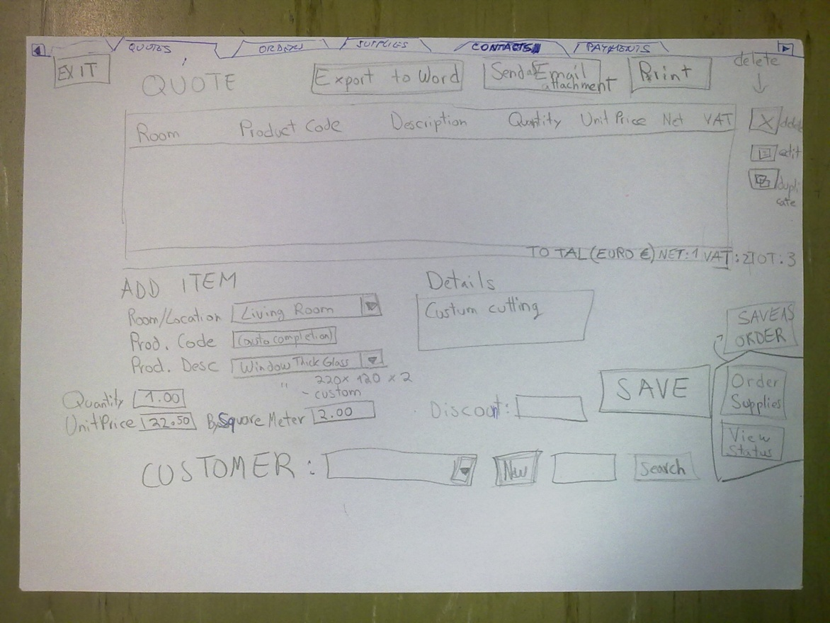

ENHANCED LOW FIDELITY PROTOTYPE
Around a page - EXAMPLE graphics below

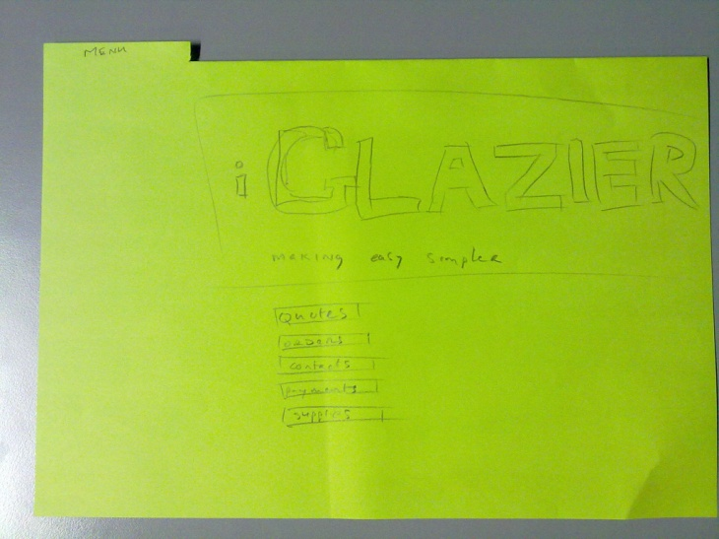 | 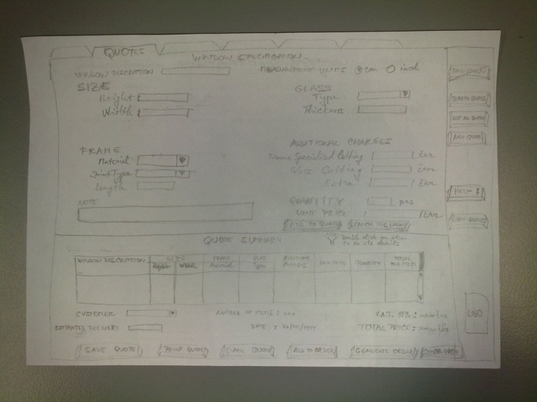
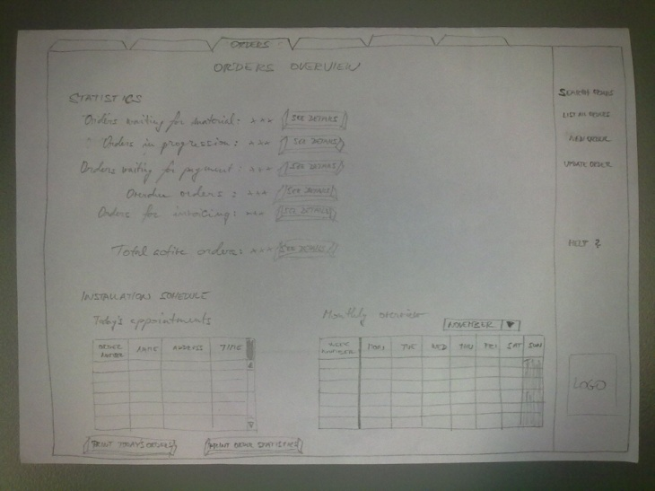 | 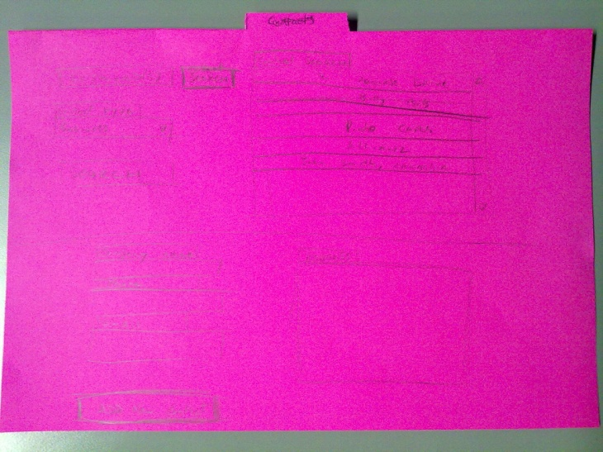
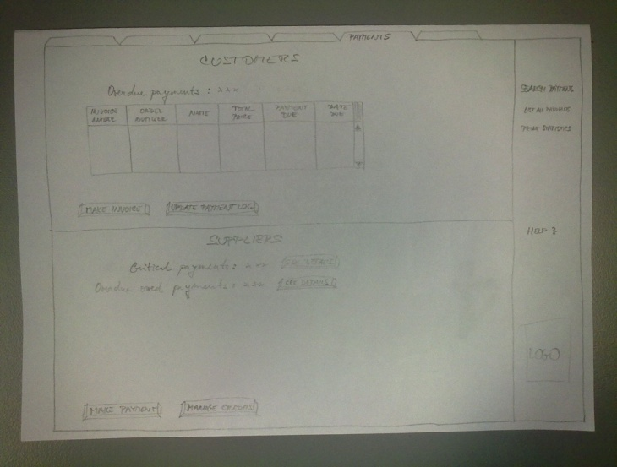 | 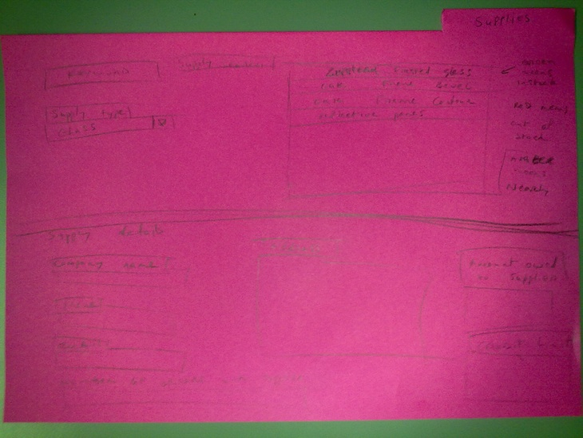

EVALUATION OF LOW FIDELITY PROTOTYPE
PREREQUISITES
Around half a page
OUTCOMES
Around half a page

MEDIUM FIDELITY PROTOTYPE
Around two pages EXAMPLE graphics below

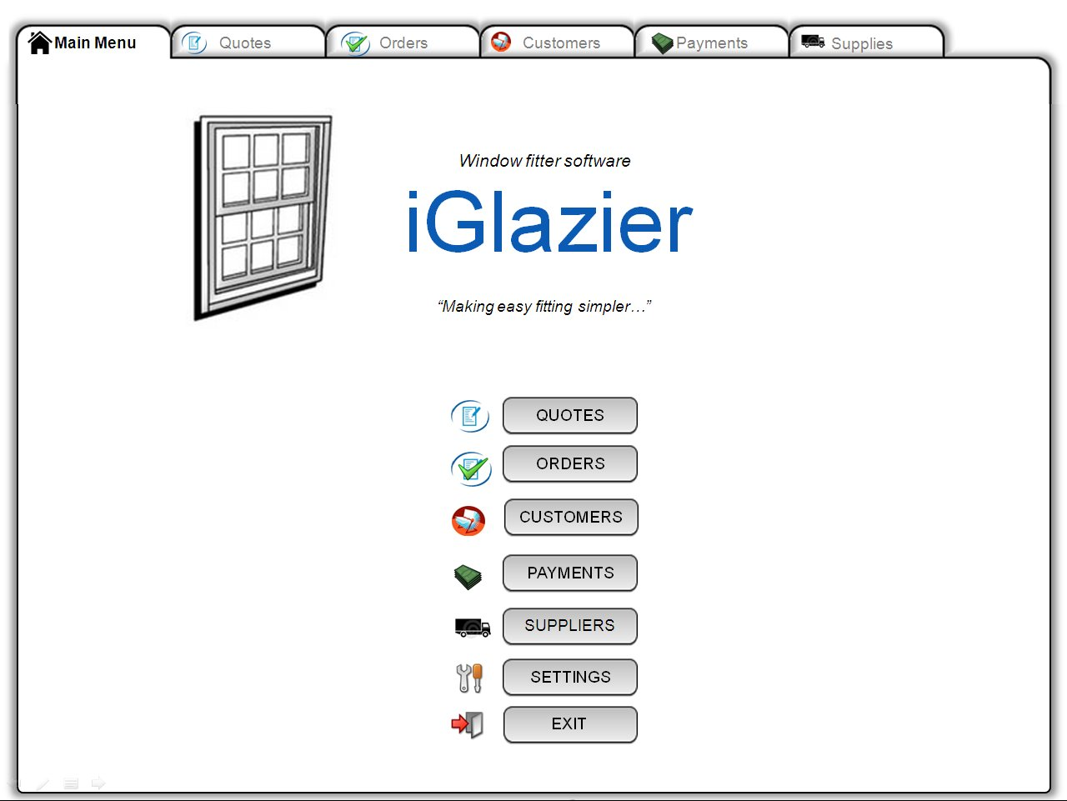

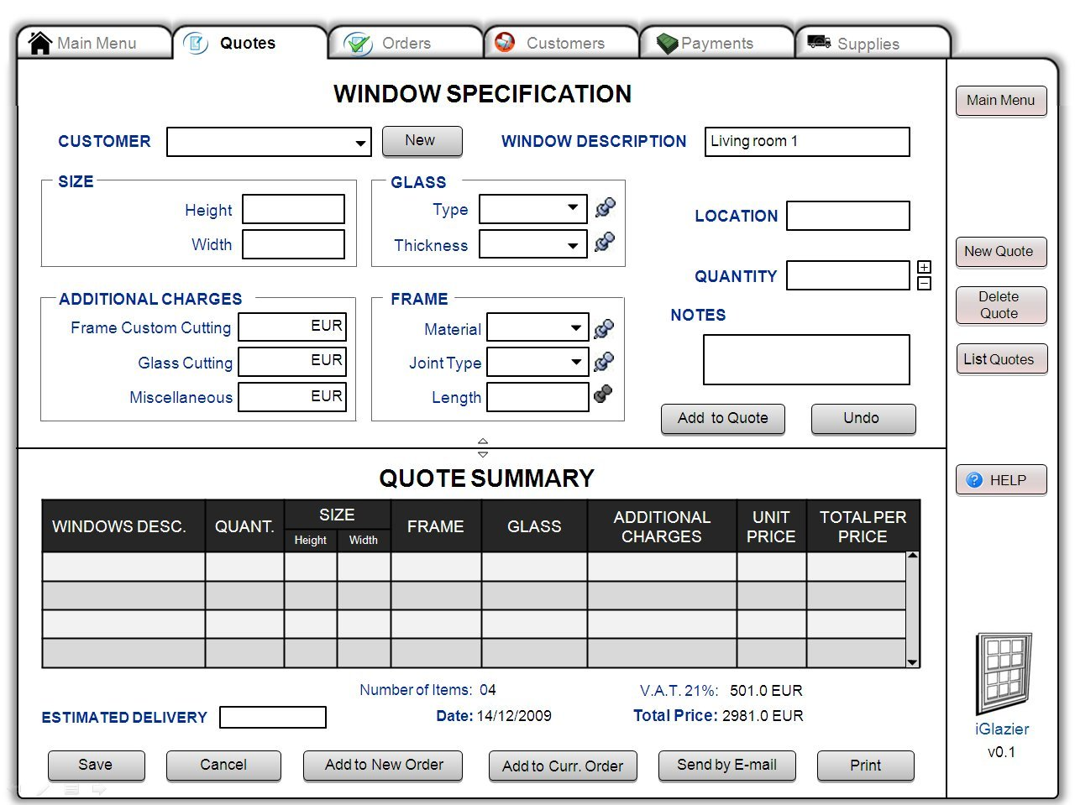
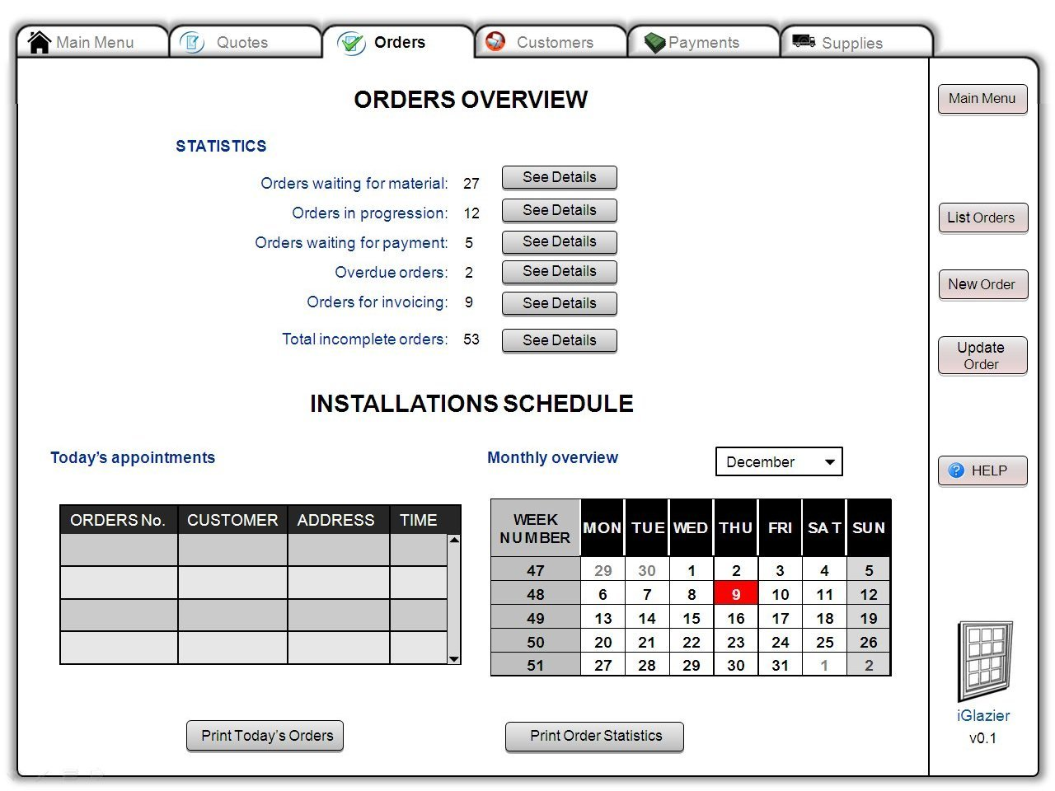

Around half a page
EVALUATION OF MEDIUM FIDELITY PROTOTYPE
Around half a page
CONCLUSION
Around half a page
REFERENCES
[Example]
- Custom Order Online, Inc. Available from: http://customorderwoodwindows.com [accessed November 2009].
- All Windows Glaziers. Available from: http://www.windowglaziers.co.uk [accessed November 2009].
- Nathan Stone Database Design - Quote Tracker: Professional Quote Management Software Available from: http://www.nathanstone.co.uk/products.html [accessed November 2009].
- Report Writing - Example format for writing a business report. Available from: http://www.howtobooks.co.uk/business/reports/report-writing.asp [accessed November 2008].
- DIY Doctor Ltd - Roof Windows. Available from: http://www.diydoctor.org.uk/projects/roofwindows.htm [accessed November 2009].
- DIY - Home Improvement, Fitting the new window frame. Available from: http://www.diynot.com/pages/wd/wd005.php [accessed November 2009].
- MyHome.ie Residential - Selecting doors and windows. Available from: http://www.myhome.ie/residential/advice-centre/1021-1110-2516/in-the-frame-selecting-doors-and-windows.asp [accessed November 2009].
- ForeUI - Easy-To-Use UI Prototyping Tool. Available from: http://www.foreui.com [accessed November 2009].
- Pidoco - wireframe creation and gui prototyping tool. Available from: http://pidoco.com [accessed November 2009].
- Prezi - The zooming presentation editor. Available from: http://prezi.com [accessed November 2009].
- Google Docs. Available from: http://docs.google.com [accessed November 2009].
- istartedsomething - PowerPoint Prototyping Toolkit (release 0.2). Available from: http://www.istartedsomething.com/20071018/powerpoint-prototype-toolkit-01/ [accessed November 2009].
- Interaction Styles - HCI, Usability, Information Architecture, User Experience, and more... Available from: http://www.interaction-design.org/encyclopedia/interaction_styles.html [accessed November 2009].
EVALUATIONS
[Example]
Team performance evaluation
Our team was gathered together based on a previous team work for an assignment in the first year. All three of us know each other well. That gave us an advantage of skipping the forming phase of the team and let us to start performing more efficiently right from the beginning.
However it took a little time to realise all the requirements necessary for this assignment. We were kind of struggling with the priorities of what to focus on primarily. The work was uncoordinated especially in starting phase.
Obviously the friendly relations amongst us did not let anybody to create some stressful work environment. That might seem being a positive fact, but on the other hand it led the team to temporarily fall behind the schedule though no strict rules were set in the first place.
The performance of the team was influenced by moving between the other three main stages of team development, storming, norming and performing. That at certain stages looked like getting us off track, but in long term it definitely allowed us to come up with better ideas thanks to some storming which had occurred and stimulated even more creative environment.
Even it might seem a bit unrealistic but like last year we succeed to avoid any potential power or leadership struggles. Every member of the team experienced each of the roles which arise within the team. For any of the sub tasks once feeling being his strong point each member took the leadership naturally and the others members followed.
Thanks to knowing each other for some time and thus being aware of each other’s strengths and weaknesses we were able to split the work and delegate responsibilities to make our performance efficient.
Self-evaluation
To evaluate myself I must say working in this team was a good experience for me. I usually tend to relay on my own abilities, having some trouble to share the work and responsibilities with others. That makes me being not objective on assessing my team mates.
On the other hand I letting myself to get under an unnecessary stress because being focused into a too much detail and kind of loosing the greater picture. That is where the other team members helped me out by refocusing my concentration back on priorities.
I had as well an issue with my poor performance during the Fridays’ labs where I was not able to come out with some consistent results. I prefer a slower peace of work especially when it is important to come up with new ideas. That is why trying to concentrate most of the performance into a two hour time slot was making me uncomfortable and loosing concentration. Again being part of the team helped me to deal with this problem and, if nothing else, at least made me to carry out the minor tasks and thus stay in touch with progress. Then later when I had more time I was able to provide the ideas needed.
Peer-evaluation
The other members of the team each having his unique abilities and own work system were the necessary balance for the team to perform.
In some cases were for example two very different suggestions were pushed forward by arguing members having the third member proved to be very effective as he was able to decide which way to go. Such decisions were well accepted which helped the team to stay focused on a single target.
With the dead line closing in every member was kind of panicking at times but the rest of the team was always able to calm down any doubts about goals being achieved.

